Project Report
1. MedSafe AI – Intelligent Medicine Safety and Prescription Analysis System
2. PROJECT DESCRIPTION
System Overview
MedSafe AI is an AI-powered medicine safety assistant that helps users analyze prescriptions, detect drug interactions, monitor symptoms, and evaluate medication risks. The system integrates Optical Character Recognition (OCR), Natural Language Processing (NLP), and rule-based risk analysis to provide users with meaningful insights about their medications.
The application allows users to upload prescription images, analyze medicine combinations, check potential drug interactions, and receive AI-generated explanations about medication safety.
Problem Domain
Medication errors and unsafe drug combinations are a major problem in healthcare. Many patients take multiple medicines without knowing potential drug interactions or side effects. Prescriptions written by doctors are often difficult to read and interpret. There is a need for an intelligent system that can:
- Interpret prescriptions
- Detect dangerous drug interactions
- Provide safety information to users
- Assist patients in understanding medication risk
MedSafe AI aims to address these issues using AI-driven automation.
Core Technology Used
The system uses the following technologies:
- Python – Core programming language
- Streamlit – Web application interface
- Tesseract OCR – Prescription text extraction
- RapidFuzz – Fuzzy matching for medicine names
- Ollama with LLaMA-3 – AI-based explanations
- Pillow – Image processing
- Rule-based Risk Engine – Medication safety evaluation
Key Capabilities
- Drug interaction detection
- Prescription OCR analysis
- Medication risk prediction

Symptom monitoring and advice

AI-generated explanations for users

Target Users

Patients taking multiple medications

Healthcare students

Pharmacists

Medical researchers

General users seeking medication safety information

Real-world Relevance

Medication safety is a global healthcare challenge. AI-based systems like MedSafe AI can help reduce medication errors, improve patient awareness, and assist healthcare professionals in identifying risky drug combinations.

3. APPLICATION SCENARIOS / USE CASES
1. Patient Usage
Patients can upload their prescriptions and check if their medicines have harmful interactions.
2. Pharmacy Assistance
Pharmacists can verify prescriptions and identify potential drug conflicts before dispensing medicines.
3. Healthcare Education
Medical students can use the system to understand drug interactions and medication safety.
4. Personal Health Monitoring
Users can track symptoms and receive AI-generated safety recommendations based on medication usage.

4. TECHNICAL ARCHITECTURE OVERVIEW
- High-level Architecture Diagram
- Component Interaction Diagram

- Component Interaction
The system contains the following modules:
- Frontend Layer
  - Streamlit interface for user interaction.
- Backend Layer
  - OCR module
  - Drug interaction engine
  - Risk analysis engine
  - Symptom analysis module
- Database Layer
  - Drug interaction database stored in Python structures.
- External Services
  - Ollama LLaMA-3 model for AI explanations.

- Data / Request Flow

- User enters medication information or uploads prescription image.
- OCR extracts text from the prescription.
- Extracted medicine names are processed using fuzzy matching.
- Risk engine analyzes possible interactions.
- AI model generates explanation.
- Results are displayed on the user interface.

5. PREREQUISITES
5.1 Software Requirements
- Python 3.10 or above
- Streamlit
- Tesseract OCR
- Ollama AI runtime
- Visual Studio Code IDE

5.2 Libraries / Frameworks / Dependencies
- streamlit
- pillow
- rapidfuzz
- pytesseract
- python-dotenv
- ollama

5.3 Hardware Requirements

Minimum system requirements:

Processor: Intel i5 or higher

RAM: 8GB recommended

Storage: 2GB free space

Operating System: Windows / Linux / macOS

6. PRIOR KNOWLEDGE REQUIRED
Concepts required before implementation:
- Python programming
- Web application development
- OCR basics
- Natural Language Processing concepts
- AI/ML fundamentals
- Software architecture principles

7. PROJECT OBJECTIVES
- Technical objectives
- Develop an AI-based medicine safety assistant
- Implement prescription OCR analysis
- Detect drug interactions using fuzzy matching
- Provide AI-generated explanations
- Performance objectives
- Provide fast response time
- Accurate medicine name detection
- Efficient risk analysis
- Deployment objectives
- Build a deployable Streamlit application
- Ensure cross-platform compatibility
- Learning outcomes
- Understanding OCR integration
- Implementing rule-based AI systems
- Building AI-powered healthcare tools
- Developing web-based AI applications

8. SYSTEM WORKFLOW
1. User Interaction
The workflow begins when the user accesses the application through the Streamlit web interface. The user can interact with the system by either entering medicine names manually, uploading a prescription image, or providing symptom information. The user selects the required feature such as drug interaction checking, prescription analysis, or symptom monitoring.

2. Input Handling
After receiving the user input, the system processes the data depending on the input type. If the user uploads a prescription image, the system captures the image file and prepares it for OCR processing. If medicine names are entered manually, the system normalizes the input by converting text into a standard format to ensure accurate matching with the medicine database.

3. Processing Logic
In this stage, the system performs several preprocessing tasks. For prescription images, the OCR module uses Tesseract to extract text from the image. The extracted text is then cleaned and parsed to identify medicine names. The system applies fuzzy string matching using RapidFuzz to compare the detected medicine names with entries in the medicine database.

4. Core System Execution
Once the medicine names are identified, the core system modules are activated. The drug interaction engine checks whether the medicines have any known interactions stored in the database. The risk prediction engine evaluates possible safety risks based on predefined rules such as conflicting medicines or symptoms. Additionally, the AI module powered by the LLaMA-3 model generates a natural language explanation of the detected risks and recommendations.

5. Output Generation
After the analysis is completed, the system prepares the results for presentation. The output may include detected medicines from the prescription, identified drug interactions, calculated risk scores, and AI-generated explanations that help the user understand the potential safety concerns.

6. Response Delivery
Finally, the results are displayed to the user through the Streamlit interface. The system presents clear messages, warnings, or recommendations regarding medication safety. The user can review the results and take appropriate actions such as consulting a healthcare professional if potential risks are detected.

9. MILESTONE 1: REQUIREMENT ANALYSIS & SYSTEM DESIGN

9.1 Problem Definition
Patients often lack information about drug interactions and medication risks. MedSafe AI addresses this by providing an automated system for medication safety analysis.

9.2 Functional Requirements
- Upload prescription images
- Extract text using OCR
- Identify medicine names
- Detect drug interactions
- Provide risk analysis
- Generate AI explanations

9.3 Non-Functional Requirements
- Fast processing time
- User-friendly interface
- Reliable AI output
- Secure system execution

9.4 System Design Decisions
The system uses a modular design where each module performs a specific function such as OCR processing, risk analysis, or AI explanation generation.

9.5 Technology Stack Selection Justification Include:
Technology | Purpose
Python | Core development
Streamlit | User interface
Tesseract | OCR processing
RapidFuzz | Medicine matching
Ollama + LLaMA3 | AI explanations

- Architecture diagram

10. MILESTONE 2: ENVIRONMENT SETUP & INITIAL CONFIGURATION
10.1 Development Environment Setup
Install Python and required libraries.

10.2 Dependency Installation
pip install streamlit pillow rapidfuzz pytesseract python-dotenv

10.3 Project Structure Creation
medsafe_ai/
│
├── main.py
├── med_db.py
├── risk_engine.py
├── symptom.py
├── ocr_utils.py
├── requirements.txt
└── README.md

10.4 Configuration Setup
Configure Tesseract path and Ollama Model

11. MILESTONE 3: CORE SYSTEM DEVELOPMENT

11.1 Feature 1 – Medicine Interaction Checker
- The Drug Interaction Checker is designed to identify potentially harmful interactions between medicines. When a user enters two or more medicine names, the system analyzes whether the combination may cause negative effects when taken together.

- Drug interactions can occur when one medicine affects the effectiveness or safety of another medicine. Such interactions may lead to reduced therapeutic effect, increased toxicity, or unexpected side effects. The purpose of this module is to alert users about these potential risks before medication is taken.

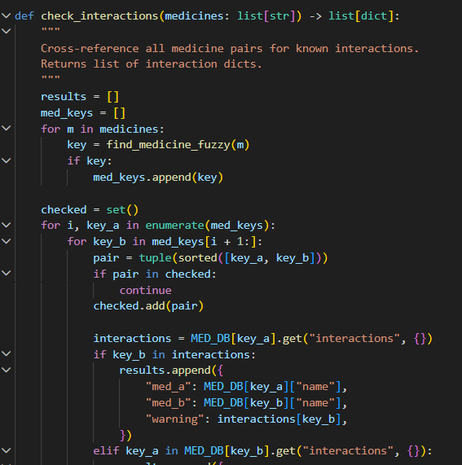

- Code Explanation
The Drug Interaction Checker module is implemented using Python and the RapidFuzz library for fuzzy string matching.

One challenge in medicine name matching is that users may enter medicine names with spelling variations, abbreviations, or typing errors. RapidFuzz solves this problem by performing approximate string matching. It compares the user input with known medicine names in the database and finds the closest match based on similarity scores.

- Screenshots / Outputs
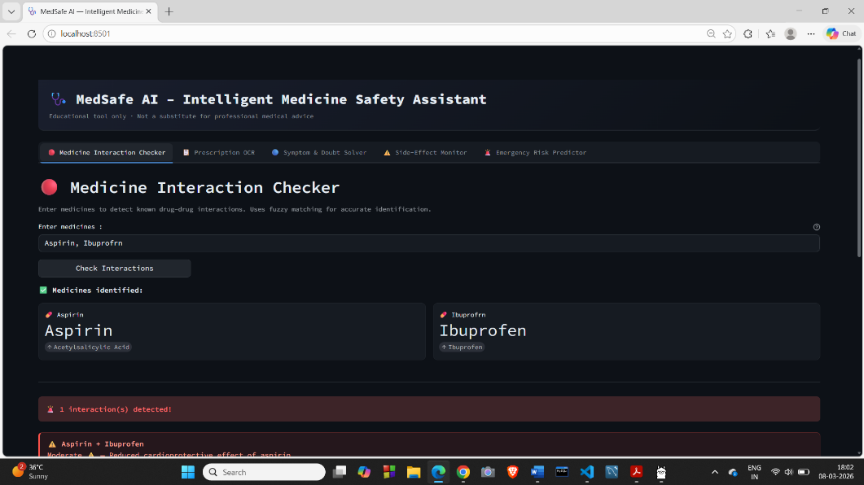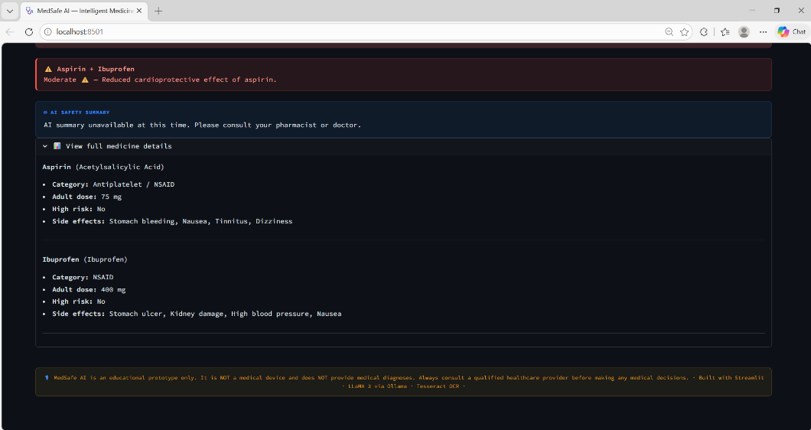

11.2 Feature 2 – Prescription OCR

The Prescription OCR module allows the system to analyze handwritten or printed medical prescriptions. Instead of manually entering medicine names, users can upload an image of a prescription, and the system automatically extracts the text and identifies the medicines listed.

This feature improves usability by reducing manual data entry and making the system more practical for real-world healthcare scenarios.

Optical Character Recognition (OCR) technology is used to convert text present in images into machine-readable text. Once the text is extracted, the system processes it further to detect possible medicine names.

- Screenshots/Output

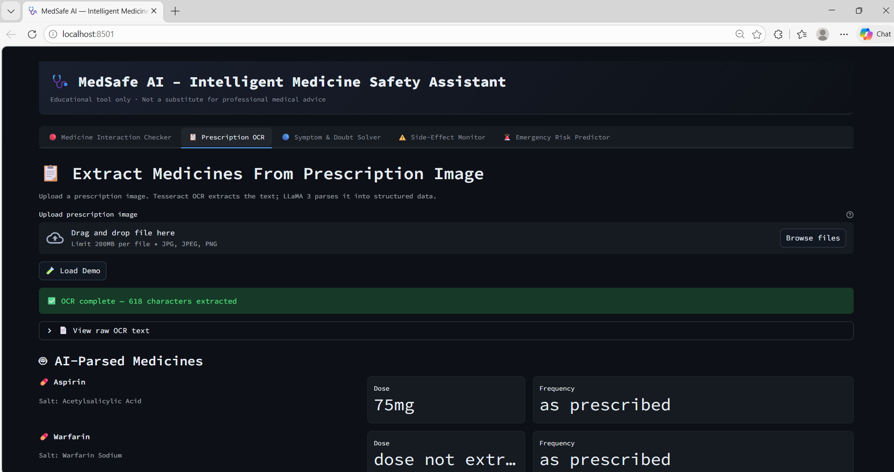
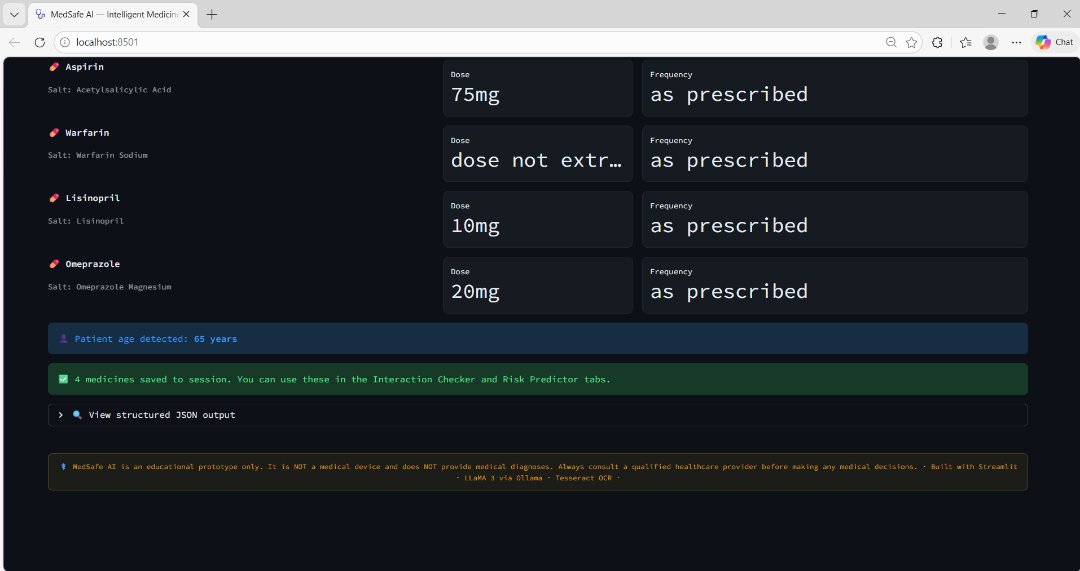

11.3 Feature 3 – System and Doubt Solver
The Risk Prediction Engine evaluates the safety of medication combinations by analyzing drug interactions and user symptoms. The purpose of this module is to provide a risk assessment that indicates whether a set of medicines may pose potential health risks.

The system uses a rule-based approach where predefined medical safety rules are applied to the detected medicines and symptoms. Each rule contributes to a risk score based on the severity of the interaction or condition.

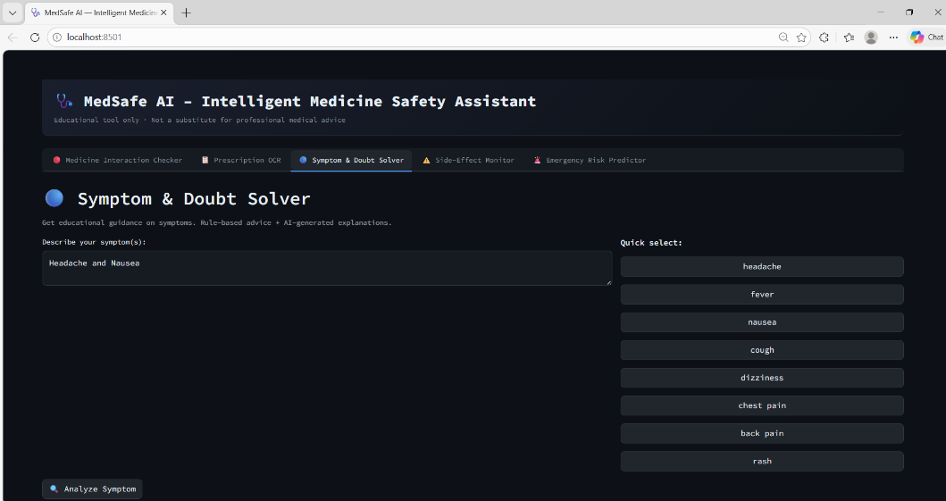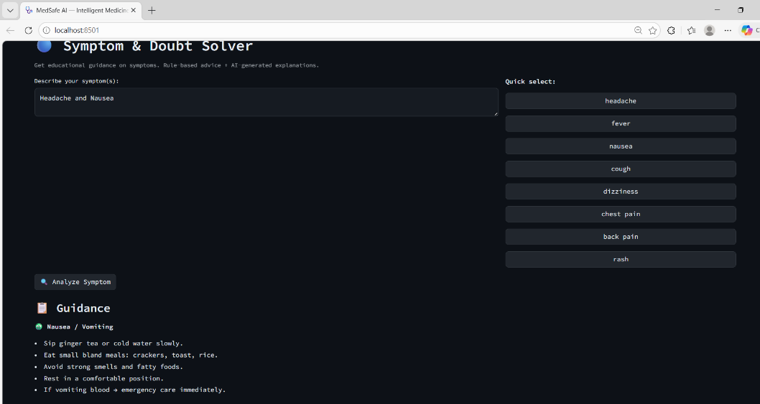

- MILESTONE 4: INTEGRATION & OPTIMIZATION
  - Component Integration
  - Performance Optimization
  - Security Enhancements
  - Error Handling & Validation

13. MILESTONE 5: TESTING & VALIDATION
13.1 Test Cases
| Test Case ID | Input | Expected Output | Status |
13.2 Unit Testing
13.3 Integration Testing
13.4 User Acceptance Testing
13.5 Performance Metrics If AI/ML:
- Accuracy
- Precision
- Recall
- F1 Score

If Web/App:
- Response time ● Load handling
- Security validation

14. DEPLOYMENT
14.1 Deployment Architecture
14.2 Hosting Platform
14.3 Deployment Steps
14.4 Production Considerations

15. PROJECT STRUCTURE
Present clean folder structure: project_root/
│
├── src/
├── config/
├── static/
├── templates/
├── database/
├── tests/
├── main_application_file
└── requirements.txt

Explain each folder.

16. RESULTS
- System Output
- Performance Evaluation
- Screenshots
- Benchmark results
17. ADVANTAGES & LIMITATIONS

● Advantages ● Limitations

18. FUTURE ENHANCEMENTS
- Scalability improvements
- Feature expansion
- Cloud integration
- Mobile integration
- Automation

19. CONCLUSION
- Summary of implementation
- Technical achievements
- Practical impact

20. APPENDIX

● Source Code ● Configuration Files ● Dataset Details (if applicable) ● API Documentation ● GitHub Repository Link ● Live Demo Link

